
Meeting Professionals International
CVENT CUSTOMER SUCCESS
U.S. and Canada (toll-free): 866.318.4357
UK (toll-free): 0808.234.4543
Australia (toll-free): 1800.502.472
All others and local: 703.226.3535

customercare@cvent.com



ATTENDEE HUB USER GUIDE

As of November 2025

Contents
Attendee Hub 3
Getting the Attendee Hub Link 4
Attendee Hub Video Session Types 5
Simulive Sessions 5
Live Stream Sessions 5
Collaborative Session 5
Configuring Virtual Attendance Tracking 5
Setting Up On Demand Videos 6
Downloading Recorded Videos 6
Troubleshooting Tips for Logging into Attendee Hub 7
Adding Moderators 7
Attendee Hub Features 7
Question and Answer 7
Live Q&A 7
Session Overview Report 7
Standard & Custom Page configuration 8
Home Page 8
Scheduling Custom Cards 8
More Menu Page 8
Custom Pages 9
Polls 9
Helpful Attendee Hub Links 9
Assistance and Resources 10
Cvent Community & Customer Care 10
Training Opportunities 10

OVERVIEW
This guide was created for use of the Attendee Hub features.

Attendee Hub
Cvent’s virtual platform called Attendee Hub to manage virtual and hybrid events. This is a separate module within the Event set up that must also be configured when utilized. The template includes some information but things like event header and session header images must be configured for use. to update the configuration of the Attendee Hub, follow the steps below.
- Navigate to the event then under Attendee Hub select Website and App.
- Then click Manage website and app.
- Adjust the theme if needed by navigating to Design > Theme.
- Then navigate to the Attendee Website and Event App Images and update any images. For details about the images and graphic sizes visit the Attendee Hub Graphics Cheat Sheet.
- When utilizing the Attendee Hub website, make sure to get the Attendee Hub Link.
  - Obtain these links through event navigation Attendee Hub > Website & App.
    - This link can only be obtained after the Attendee Hub has been configured and promoted to Live. Click here to review this process.
  - Before the Attendee Hub is launched it will look like this:
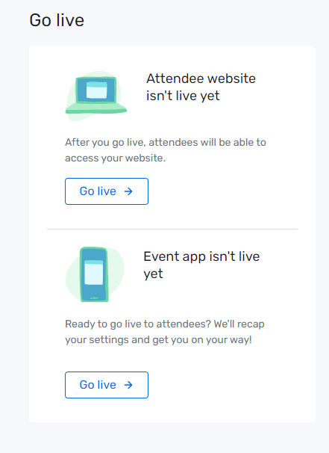
- Once launched, an Attendee Hub link will appear unique to that event.
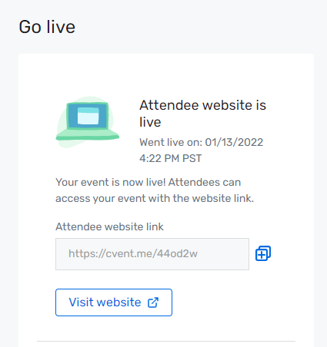
- Testing first requires registration for the event. The link will prompt for information to verify registration.
- A verification email will be sent via email. Input that code into the next screen to access the Attendee Hub – then click Log In.
- This will allow the preview of the live site with any updates that have been made.
- The last step, once the event is launched, is to register and login to the Attendee Hub and verify that everything looks as expected.

Getting the Attendee Hub Link
It is important to tell attendees how to get to the Attendee Hub. Provide registered participants a direct link to the Attendee Hub found in the Attendee Hub Configuration page.
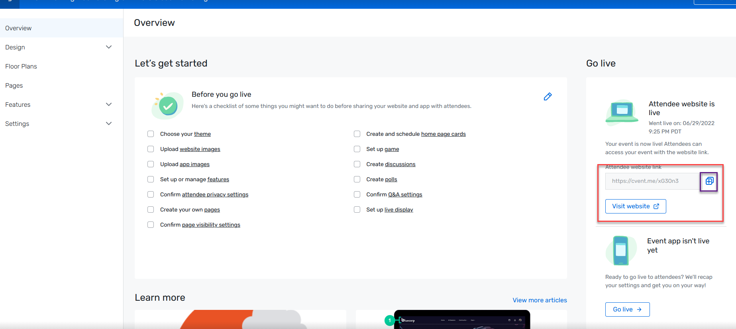
-Or- share the link using the “My Event Link” via email or on the confirmation page. For additional directions please review this article.

Attendee Hub Video Session Types

Simulive Sessions
- Click Session List under Agenda.
- Select a session.
- Click on the Video Settings tab, then Edit.
- Select Pre-recorded in the Session Setup section.
- Choose a Video Player.
- Set Is this a simulated live session to Yes.
- Choose whether to start playing content at the session start time, or up to five minutes before.
- Choose whether or not the recording should be available as an on-demand video.
- Click Save.
- From the Video Settings tab, click Upload in the Video section on the right.
  - Videos must be less than 15GB and in mpg2, mov, mp4, mpe, mpeg, mpg, mpv, qt, or webm format.
- To use a video previously uploaded for another session within the same account, click Choose from Library instead.
- When the video is ready, a checkmark will appear next to the message "[Video name] has been uploaded, and a frame from the video will be displayed as the thumbnail by default. Choose if the video should be included in the account library and click Replace thumbnail to upload a custom thumbnail, if desired.
- Click Done.

Live Stream Sessions
- To add virtual meeting information, go to the navigation bar, select Session List from the dropdown menu under Agenda.
- Open the session and choose the Video Settings tab.
- Click Edit.
- Select Live and under Session Type select Live stream.
- Choose the Video Conferencing Tool as Cvent (powered by Zoom), Studio, or External platform.
- Select the necessary virtual information and click Save.
- Repeat the process for the remaining virtual sessions.

Collaborative Session
- To add virtual meeting information, go to the navigation bar, select Session List from the dropdown menu under Agenda.
- Open a session and choose the Video Settings tab.
- Click Edit.
- Choose if it will be a Live or a Pre-recorded session.
- Choose the virtual platform as Cvent Video Conferencing (powered by Zoom), Cvent Video Conferencing (embedded) or External platform.
- Select the necessary virtual information and click Save.
- Repeat the process for the remaining virtual sessions.

Configuring Virtual Attendance Tracking
- Navigate to a session from Agenda and then Session List.
- Click the Advanced Settings tab, then Edit.
- In the Virtual Attendance Tracking section, decide if attendee participation should be counted as soon as an attendee joins the session, or after they've watched the session video for a certain amount of time.
- If participation is set to be time-based, choose how many minutes of the session an attendee must watch to be marked as a participant.
- Then determine if attendees must watch the session during its scheduled time to be counted as a participant, or if they'll still be marked as a participant if they watch it later on-demand.
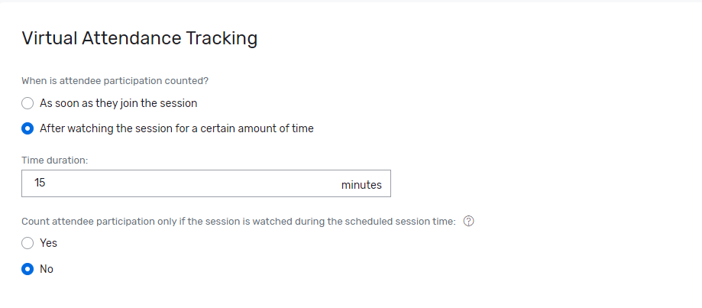
- When finished, click Save.
NOTE: Duration-based session tracking is not available for collaborative sessions or virtual sessions with an external video player or link that takes users outside of the Attendee Website to watch video content.

Setting Up On Demand Videos
- Navigate to a session from Agenda and then Session List.
- Click on Virtual Event tab.
- Select Cvent Video Player under Video Player.
- Choose Available as an on-demand video.
- Click Save.
- By default, attendees have access to the On Demand page when a session video is available to view on demand. To view the On Demand sessions, follow these steps:
  - Log in to the Attendee Hub website.
  - Under Schedule select On Demand.
  - Choose from the available on demand sessions.

Downloading Recorded Videos
For Cvent live stream sessions that are set to be recorded and Cvent Video Conferencing collaborative sessions recorded by the assigned host, it is possible to download the recording from Cvent.
- Navigate to a session.
- Click on Virtual Event tab.
- Hover over the Actions drop-down menu.
- Select Download recording.

Troubleshooting Tips for Logging into Attendee Hub
This article highlights tips for attendees who are having trouble logging into the Attendee Hub.

Adding Moderators
Using moderator permissions, choose anyone from the attendee list to act as a host, speaker, or audience engagement monitor for the Attendee Hub sessions. Read more about moderators here.
- Session moderator- Engagement monitors keep an eye on engagement tools like session chat, live Q&A, or live polling.
  - Session level Audience engagement Moderator-At the session level this person can only moderate the particular session. This is done at the session level.
Global level Audience engagement Moderator-At the event level this person can moderate any session. This is done from their invitee record.
- Speaker moderators- Join the session or live stream as the speaker. Make presenters a speaker moderator.
- Video host moderator- Join as the live stream or session host and be able to start and stop the video. Make the lead contact the video host. This should also be the director if using study.
Review this article for instructions on sharing the zoom link in advance.

Attendee Hub Features

Question and Answer
Participants will be able to ask questions during the Attendee Hub session. To learn more about setting up Q&A, click here. To learn more about moderating Q&A sessions, click here. This page may be helpful to send to moderators in advance.

Live Q&A
Use Live Q&A to enable attendees to submit questions during a session right from the Attendee Website or Event App. Follow the steps mentioned below. Click here for the article on the Cvent Support Community.
- Expand Attendee Hub on the left navigation bar.
- Click on Website and App.
- Click on Manage Website and app.
- Click on Features > Session Content on the left navigation bar.
- Confirm Q&A is set up for the needed sessions.
- If desired, add a moderator to decide which ones are visible to other attendees and displayed live. A moderator can be anyone who is an event registrant.
To pull a report of Q&A:

Session Overview Report
- Go to Reports>Reports.
- Find the report called Session Overview > scroll to Sessions List widget> locate row for session > scroll to “Questions Asked” column > click number in column.
- This report also shows written responses.

Standard & Custom Page configuration
This section allows for the configuration of home page content and creation of custom pages.

Home Page
- Expand Attendee Hub on the left navigation bar.
- Click on Website and App.
- Click on Manage Website and app.
- Click Pages under the left navigation bar.
- Click Edit Home Page.
- Add & reorder Quick Links on the home page. (Event App only)
- Select the Add Card button in the top right-hand corner.
- Select from the following list.
  - Single link card - Highlights a single link.
  - Link gallery card - Highlights multiple links.
  - Single video card - Highlights a single video link.
  - Video gallery card - Highlights multiple video links.
- Once cards have been added, select Schedule Your Cards to schedule when cards will appear.
- Click Save Page.

Scheduling Custom Cards
Cards contain the content on the Attendee Website's Home page and Event App's Home tab. Use the card scheduler to control when adjustable cards, which link to a page within the event, and custom cards, which link out to another webpage, should appear to attendees. Cards can be schedule up to 90 days before or after the event. More information about scheduling cards can be found here.

More Menu Page
- Log into Cvent and navigate to the event.
- Expand Attendee Hub on the left navigation bar.
- Click on Website and App.
- Click on Manage Website and app.
- Click Pages under the left navigation bar.
- Find the More menu section below.
- Click on Create Section.
- Add a Name.
- Add an optional Description.
- Click on Done.
- Reorder/Position pages & sections at the right places.
- Enable the Event Description (About) & Event Location to be shown.
- Click Update Page.

Custom Pages
Additional customization options are available. Directions for adding web or video links to the Attendee Hub can be found here. Note the layout of this page will be updating soon.
- Log into Cvent and navigate to the event.
- Expand Attendee Hub on the left navigation bar.
- Click on Website and App.
- Click on Manage Website and app.
- Click Pages under the left navigation bar.
- Click on Create page.
- Choose if this will be a custom page or an external link.
- Insert a page name & click on Done.
- Select a Page Icon from the list & click on Done.
- Upload an optional header image as per the recommended dimensions.
- Add page content under Page description.
- Add hyperlinks by insert text > highlighting the text & clicking on the hyperlink icon.
- Click Save page.
Click Here to learn more about customizing Attendee Hub Pages
Click Here to learn more about creating custom pages.

Polls
With live polling, attendees can respond to questions created and view the results in real-time during a session. A moderator will have full control over when the questions open for responses and which ones should be displayed live. Follow the steps mentioned below to configure Polls. Click here for the article on the Cvent Support Community.
- Log into Cvent and navigate to the Event Template.
- Expand Attendee Hub on the left navigation bar.
- Click on Website and App.
- Click on Manage Website and app.
- Click on Features > Session Content on the left navigation bar.
- Click Set up next to Polls.
- Click Create poll to create a poll from scratch.
- Add Poll questions by clicking Add question.
- Re-arrange Poll questions by dragging and dropping them using the drag reorder icon.
- Assign the poll to sessions by clicking on the Assign sessions tab and selecting the session.
- Click Done and click Update poll at the top right.

Helpful Attendee Hub Links
- Assigning Attendee Hub Permissions
- Enabling Attendee Hub in an Event
- Configuring Virtual Sessions
- Designing Attendee Hub Website and App
- Designing Home & Custom Pages
- Configuring Attendee Hub Settings
- Publishing the Attendee Hub Website & Event App
- Attendee Hub Metrics
- Attendee Hub Checklist

Assistance and Resources
- Reach out to the System Administrators during normal business hours for assistance
  - Srishti Mishra
    - Srishti.Mishra@cvent.com
  - Shoaib Mauloodi
    - MShoaibmauloodi@cvent.com
- Access the Cvent Support Center from within your account for knowledge base articles, training and case submission by clicking on the Cvent Community chat icon.
- For urgent issues, use the premium support line (US: 855.332.2728; international numbers in Support Center).
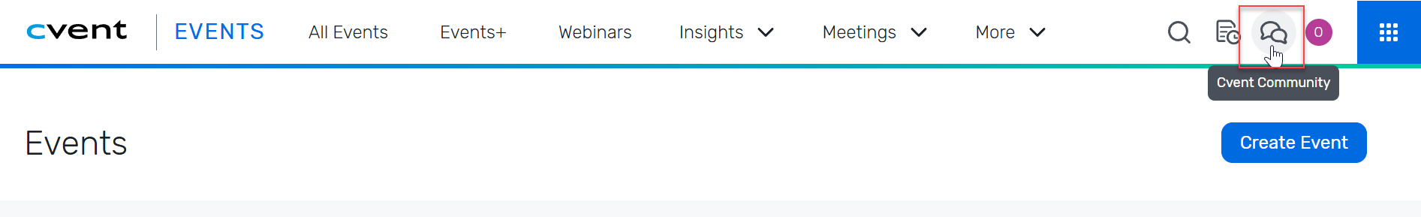

Cvent Community & Customer Care
The following resources can be found and explored by going to https://community.cvent.com/home.

Training Opportunities
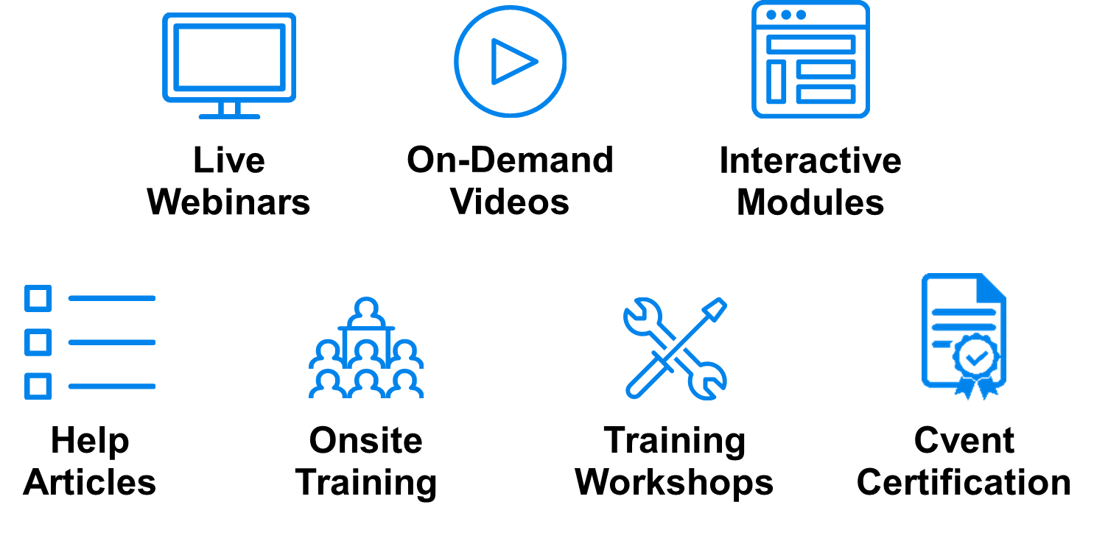
The following training opportunities can be found and explored by going to https://community.cvent.com/training.

