RISE Winner

**Mexico Chapter**

# Marketplace Excellence – Planner Sponsored Tables at In-Person and Educational Events

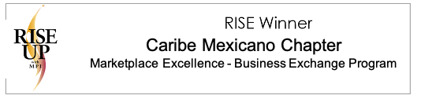

# MPI Mexico Chapter- Marketplace Excellence

# Planner Sponsored Tables at In-Person and Educational Events

## Objective: Attract qualified planners to monthly educational events and add value to supplier membership by offering table sponsorship opportunities.

## Why: By increasing relationship opportunities for planners and suppliers, an increase in chapter membership was anticipated.

## When: During In-person and Educational Events

## What:

## Define your objectives, creating specific, measurable goals. Develop a detailed timeline to ensure the strategy stays on track.

## Sell educational event VIP zones and/or tables to sponsors.

* Each table sold for $1,000 USD (normal registration fees are $15 for members and $25 for non-members), which gave the sponsor the opportunity to host 9 meeting planners for a 2-3 hour long educational event. These tables replaced 9 business appointments in the same space and provided networking, relationship development and promotional opportunities.

## Promote meeting planner participation by emphasizing the value created to attend and represent themselves at the sponsored tables as a concentrated networking space. Promote thru social media, chapter newsletter, new member welcomes, post-event pictures and testimonials.

* Selecting Participants: VP Commercial, VP Events and VP Education worked together to decide the educational event’s content or key speaker to be attractive for the industry and evaluate if the event would offer sponsored tables. In that case, the chapter promoted it as a free event for Meeting Planners, who may register by completing a pre-selection profile questionnaire. Sponsors then selected the planners they chose to invite to their tables.

## Results:

## Sponsors receive a tangible communication tool for MPI members to advertise their services and offer business expertise, creating sponsorship ROI.

## Chapter members receive added value to increase business networking and foster relationships within the chapter.

## Capture and maintain the attention of members who stay connected.

## Outcome Summary

## By analyzing monthly educational event attendees to target and identify their needs versus their expectations from MPI, we were able to pinpoint the specific value suppliers and sponsors needed to maintain engagement and increase chapter membership. By raising the number of planners at chapter events, suppliers had direct access to their ideal client. Likewise, planners were able to express exactly what they needed to their audience of suppliers. These deeper connections provided an opportunity for the chapter to tailor educational content that speaks directly to our membership.

## As the professional value of our membership raises, we are committing to empower private industry and create marketplace opportunities for all, elevating our competitiveness as a strong industry with an even stronger foundation. Our new industry positioning creates additional business opportunities, giving MPI a seat in the Global Meetings and Events profession. RFPs for educational meetings, live events and the like are enhancing destinations and commercial allies to establish a LOUD MESSAGE: Together we are stronger.

# New Technology Development

Our chapter launched a mobile application with detailed chapter information: members, Board of Directors, venues and sponsors with relevant industry articles. We also included available short video tutorials that serve as training for the app users.

We broadcast a portion of our educational events via streaming and Facebook Live, which gives us the opportunity to achieve new brand positioning throughout the country, not only in the local area. These videos are also available to be viewed and shared Globally.

**Program Impact on MPI Community**

Our chapter had a significant increase in membership, which was needed after our membership numbers dwindled when a new chapter was created in our country. We continue to grow and can directly associate the implementation of planner sponsored tables and the chapter app with this success.

**Communication Tools**

Customized emails are sent to all MPI Mexico members, sponsors, allies and community. Chapter social media is a key communication tool: Facebook, Twitter, Instagram, LinkedIn and a YouTube channel.

**Program Reach**

Chapter membership has grown exponentially. Education program attendance is up. Attendance to all our events are up and survey scores continue to rise as our attendees are satisfied with content.

We have been working with other chapters to search for new meeting and event opportunities, but also firm up meeting planner and supplier relationships. On top of everything, we are providing a strong networking web across the country to stay connected globally.

**Supporting Photos**

* The sponsored tables were part of a commercial strategy called Win to Win.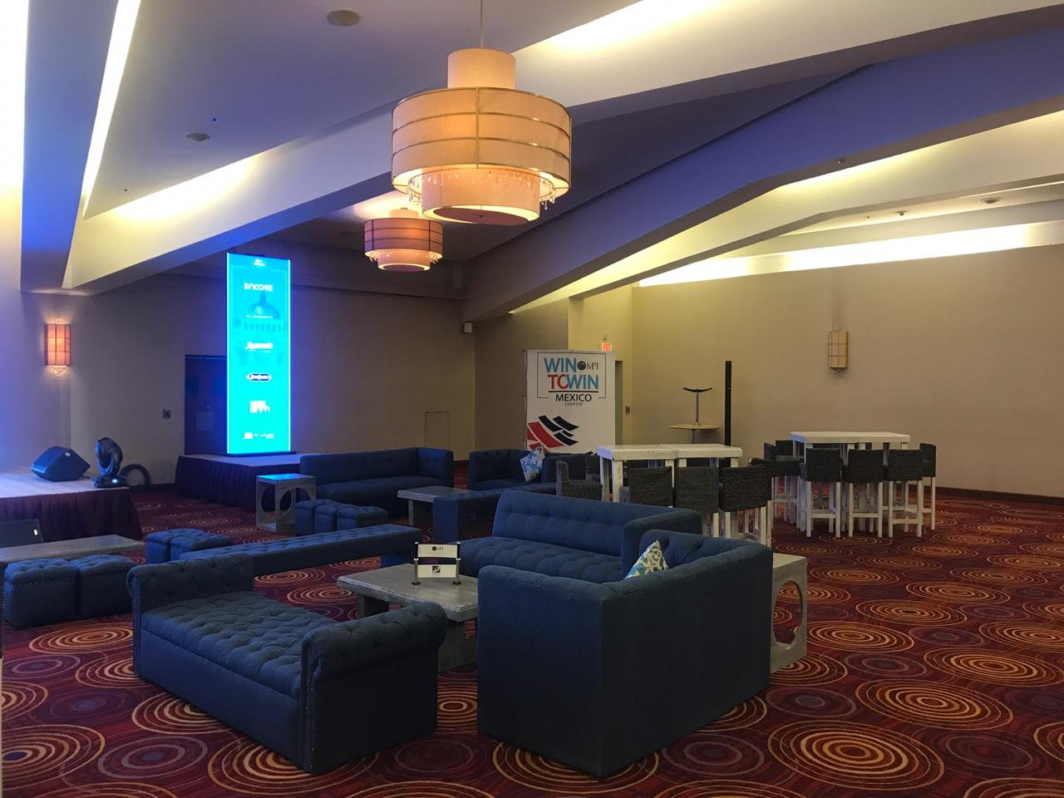
* Participants were identified at the event via lounge areas near or at the front stage.

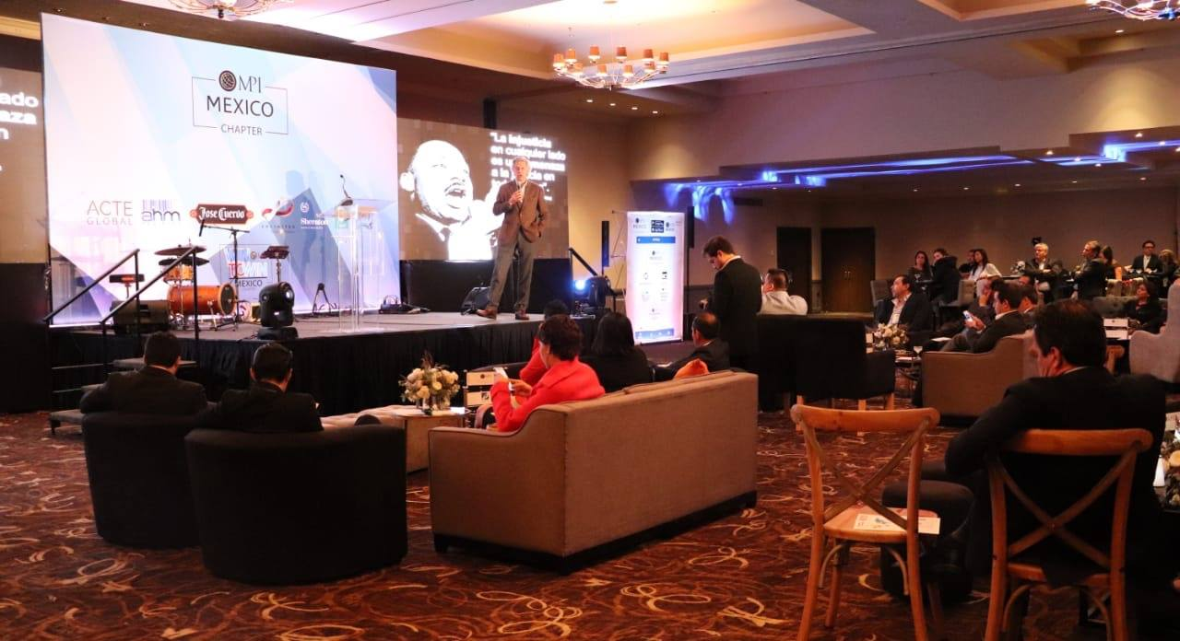

* Each table had a small MPI banner

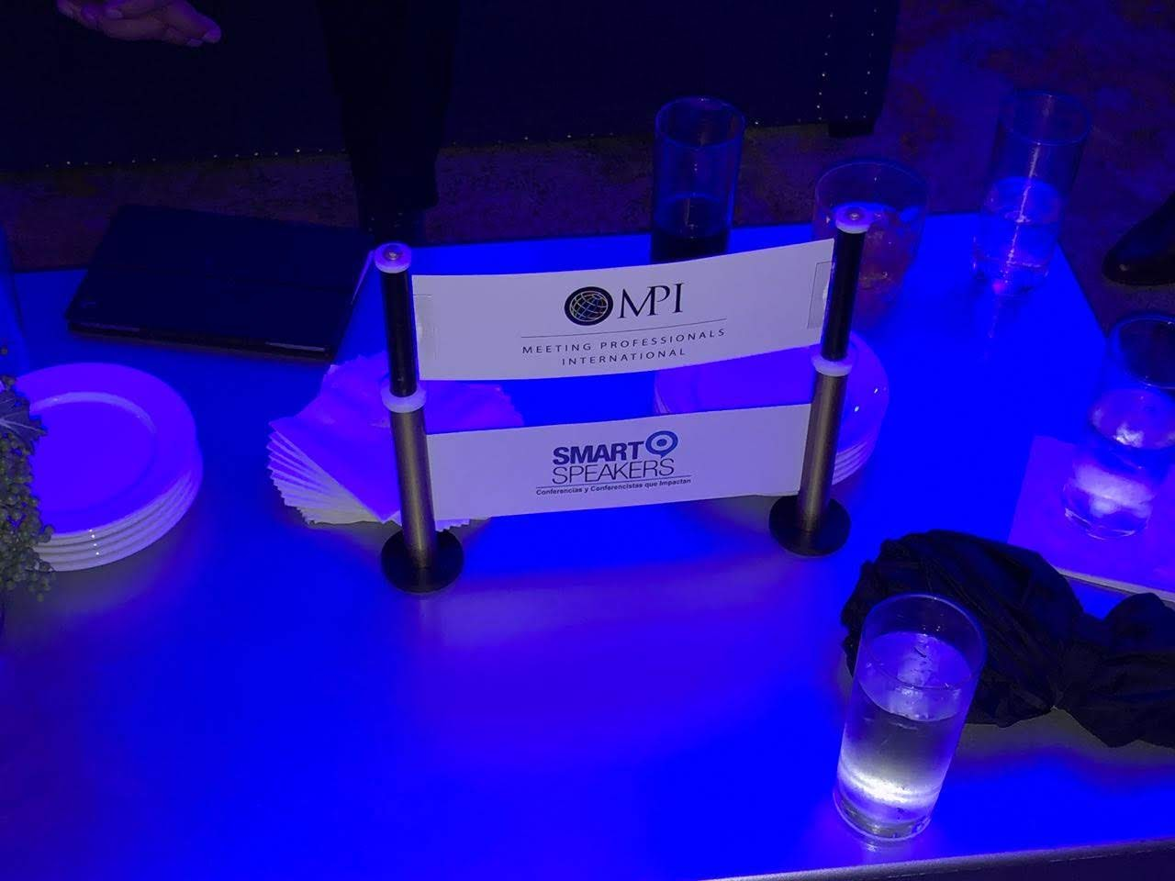

* The VIP areas also give sponsors the opportunity to personalize the table with promotional flyers, amenities and gifts for selected planners.

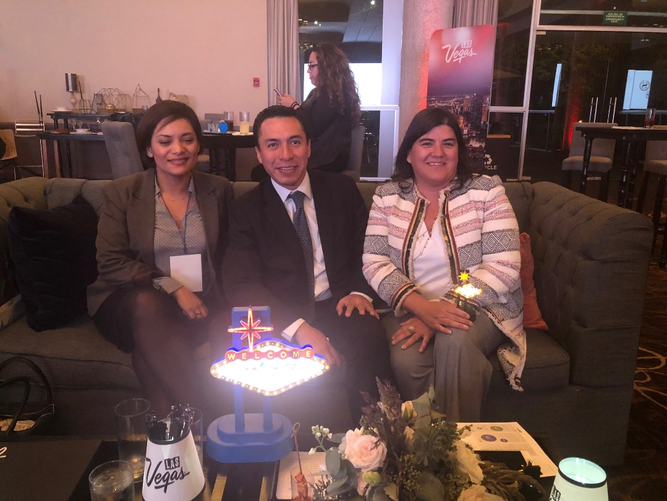

* This effort made the sponsored tables a low-cost sponsorship opportunity available at every educational event.

