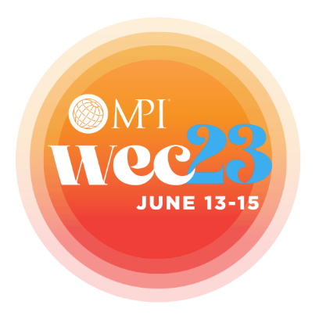

Dear [BOSS],

I am eager to share a growth opportunity for both our business and my own professional development.

Meeting Professionals International (MPI) hosts an annual event called the World Education Congress (WEC) that consistently provides actionable education and facilitated business connections for meeting and event professionals, helping them and their organizations exceed goals, objectives and KPIs.

The conference’s metrics for networking, education and relevance regularly exceed 90 percent—an industry-leading high.

This coming year, the focus of WEC23 is a refreshed mindset for this new era of meetings and events, providing education and connections that will help me design and execute successful events that deliver meaningful change for our company.

I’ll learn about new technologies that are impacting attendee experience; methodologies for innovation and creativity; strategic alignment to overarching business goals; and critical skills like negotiation, change management and stakeholder engagement. This is the best opportunity for our business to learn more about the role meetings play in competitive advantage, KPI achievement and long-term success.

WEC23 will also save us much-valued time as a business. Our biggest partners—from hotels and venues to audiovisual and technology companies to worldwide destinations—will be in attendance. I can meet with multiple suppliers to source facilities and services all in one location, replacing hundreds of phone calls and emails.

I will also meet face-to-face with peers and colleagues, expanding our business network and providing long-term mutual benefit for our company.

Ultimately, WEC23 presents us with the best opportunity for gaining the knowledge we need to create new, cutting-edge in-person experiences and ensure that we successfully use meetings and events to impact our business and our bottom line.

The cost to attend is far less than the value incurred. For [insert cost], I will gain many times the equivalent in education and business connections.

With your support, I will book today, so I can prepare our organization for the new era of events. If you want more information, visit mpi.org/wec.

Thank you,

[INSERT CONTACT INFO]

