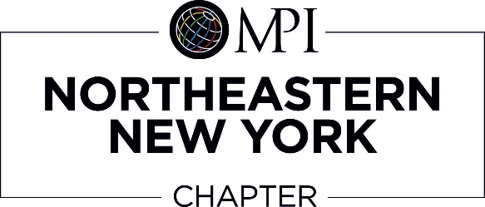

MPI NENY PROFESSIONAL DEVELOPMENT
CERTIFIED MEETING PROFESSIONAL (CMP) SCHOLARSHIP PROGRAM
This scholarship is awarded once a year in June.
The deadline for the 2018-2019 Scholarship Application is Monday June 3rd, 2019 at 5pm.
Scholarship Eligibility Criteria: You must be a current MPI member, have passed the CMP Exam in the current year
(July 1, 2018– June 30, 2019), and not be financially supported by your employer in this endeavor.
2018-2019 APPLICATION FORM
Name of applicant:______________________________________________________________________
Address:___________________________________________________________________________
E-Mail Address:_______________________________________________________________________
Phone:___________________________________________________________________________
Length of time employed as a Meeting Professional:______________________________________________
Date of your CMP exam:________________________________________________________________
Application for CMP and receipt of passing the exam must be attached.
ESSAY: Please attach a 250 word essay on why you are pursuing the CMP Certification and how it will contribute to your development.
COSTS:
Application Fee: $_______
Registration Fee: $_______
TOTAL COST: $ _______
AMOUNT OF SCHOLARSHIP REQUEST: _____________ (not to exceed $500.00)
DOCUMENTATION:
Please submit the following along with this completed application to:
MPI NENY
P.O. Box 3261
Saratoga Springs, NY 12866
  - Copy of your CMP application
  - Copy of your receipt of passing the exam
  - Essay as described above
  - Personal out-of-pocket receipts
APPLICANT'S SIGNATURE DATE: ___/___/___
CMP COMMITTEE SIGNATURE DATE: ___/___/___

