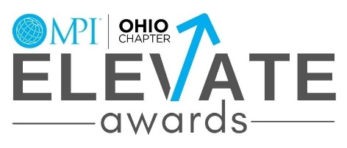
June 2022 Recognition & Appreciation Event

Company:
List name as you would like it to appear on all materials
Contact Name:
Email:
Street Address:
City, State, Zip:
Phone:

Sponsorship Level:

Platinum $1000 Gold $500 Silver $250 Bronze $150 Table $300 In Kind Donation

Please describe In Kind donation: _ ____________________________________________________________
_______________________________________________________. Value of In Kind Donation $_ _______
Credit Cards or checks are accepted for sponsorships. Please indicate which payment form by checking the box below.
VISA MasterCard Amex Discover Check
Card No.: |  |  |  | CCV No.: |  |  |  |  |  | Expiration Date:
 |  |  |  |  |  |  |  |  |  |  |  | (MM/YY)
Amount to charge: |  | $ | Name on card:
Billing Address:
City: |  |  |  |  |  |  | State: |  | Zip:
Checks should be made payable to MPI Ohio and sent to:  MPI Ohio  4010 Executive Park Drive, Suite 100  Cincinnati, OH 45241 |  |  |  |  |  |  | All Sponsorship Payments are due by: June 1, 2022
Signature:

Thank you for your sponsorship!
Please send your logo to admin@mpioh.org at your earliest convenience.

