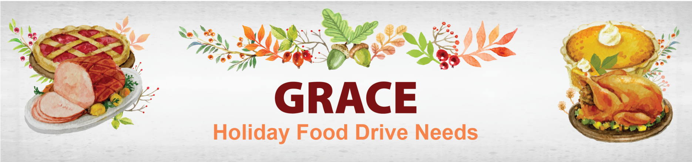

Thanks to your generous support GRACE was able to provide 405 Thanksgiving meals and 372 Christmas meals to families in need. The estimated value of each food basket is $75.00.
Shopping List

- Sweet Potatoes
- Canned Fruit
- Instant Potatoes
- Cranberry Sauce
- Canned Chicken Broth
- Canned Mushroom Soup (10.5oz)
- Sugar (2 or 5 lb)
- Flour (2 or 4lb)
- Cooking Oil
- Instant Stuffing
- Gravy (instant or canned)
- Pancake Mix
- Syrup
- Canned Pumpkin
- French Fried Onions (6oz)

Please bring your items to the luncheon and The Hilton DFW Lakes will ensure they are dropped off.
About the GRACE Food Pantry:
The Client Choice Food Pantry provides perishable and non-perishable food to individuals and families in need. The Food Pantry utilizes a voucher system for GRACE clients to shop and select the food items that meet the cultural and dietary needs of their households.

