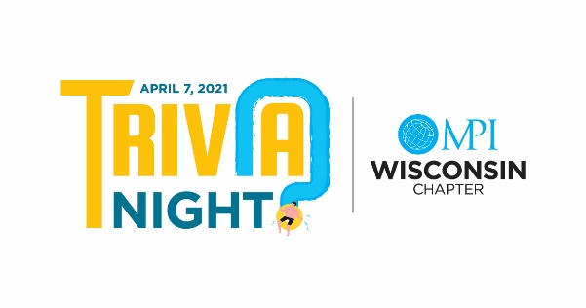

SILENT AUCTION AND IN-KIND DONATIONS FOR MPI-WI TRIVIA NIGHT 2021
To be held at the Kalahari Resort, Wisconsin Dells, WI

Donating Company: _____________________________________________________________________

Donating Company’s Contact Person: _______________________________________________________

Contact Person’s Email Address: ___________________________________________________________

Contact Person’s Phone Number: __________________________________________________________

Item or Items to be donated: _______________________________________________________________

Value of Item(s) being donated: ____________________________________________________________

 I will mail my donation (must receive by 3/15/21)  I will arrange delivery/pickup with Trivia team

Donations should be mailed to either of these addresses
Wanda Gilles Christopher Dyer
6487 S Windsor Prairie Road Meeting Professionals Int’I-Wisconsin
Deforest, WI 53532 2820 Walton Commons Suite 103
Madison, WI 53718

Return this form to Wanda Gilles at wanda.gilles@yahoo.com

SPONSORSHIP FOR MPI-WI TRIVIA NIGHT 2021

SPONSORSHIP OPPORTUNITIES
A great way to showcase your product and services to MPI-WI chapter planners and suppliers.

Title Sponsor ~ $2,000

Includes logo on every slide, table sponsor, two trivia questions, recognition throughout event,
recognition in our quarterly newsletter (the Agenda) and on social media pre and post event.

Table Sponsor ~ $500

Includes table at trivia where a team will be assigned to your table (unless you have a team
of your own!) We encourage you to be a part of this team and participate. During break
times, other attendees will visit your table. Anyone who visits your table (including your own
team) receives a stamp/sticker on their trivia passport. Recognition in our quarterly newsletter
(The Agenda) and on social media pre and post event.

Question Sponsor ~ $250

Recognition during a category question with company logo/shout out. Recognition in our
quarterly newsletter (The Agenda) and on social media pre and post event.
…more options on other side…

Passport Sponsor ~ $500

Company logo on Passports, which are given out to each attendee, they will get bonus points for
visiting sponsor tables. Recognition in our quarterly newsletter (The Agenda) and on social
media pre and post event.

Drink Sponsor ~ $1,000

Reception Beverages - Multiple Signs on Bars that provides publicity for your company with
an appreciation statement using your logo. Recognition in our quarterly newsletter (The
Agenda) and on social media pre and post event.

Quiz Master ~ $1,000

Includes logo on answer cards, table sponsor, and one trivia question. Recognition in our
quarterly newsletter (The Agenda) and on social media pre and post event.

Reception Sponsor ~ $1,000

Reception food. Multiple signs on reception table with your company logo and appreciation
statement. Recognition in our quarterly newsletter (The Agenda) and on social media pre and
post event.

Printing Sponsor ~ $500

Logo on answer cards. Recognition in our quarterly newsletter (The Agenda) and on social
media pre and post event.

*All sponsors will be recognized on the MPI-WI website, email blasts, and program slide show

