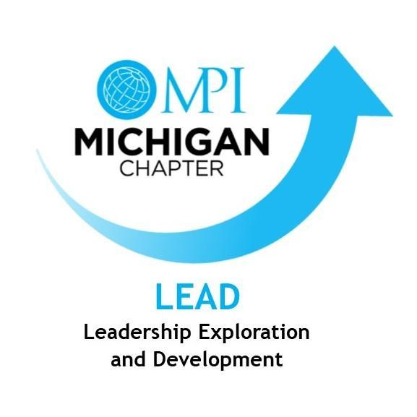

MPI Michigan Mentorship Program
Mentor/Mentee Guidebook

OVERVIEW
Purpose
The Program matches individuals new to the industry or individuals looking to grow their career with seasoned volunteer professionals so that they may share information, knowledge, and ideas in an open and non-threatening environment. The goal of the program is to match learners with teachers to foster the reciprocal flow of information and advance the meetings & events profession.
MPI Michigan Chapter Mentor Information
Program information is available here or by emailing Sarah Dysinger, sarah.dysinger@gmail.com.
What is a Mentor?
The dictionary defines a “mentor” as “an experienced and trusted advisor.” The program defines this as experienced industry professionals who are active in their profession and who have a desire to share their experience and knowledge to help contribute to the success of future leaders. Mentors can be planners or suppliers, so long as they have a depth of knowledge and experience that would be valuable to someone new to the profession.
Mentors support the mentee in meeting his or her goals through questioning, providing guidance and feedback, sharing his or her own experiences, and possibly connecting the mentor with other individuals or groups who could help. As a mentor you are able to contribute in several ways offering:
- Goal Setting: Mentors help mentees discover talents and interests and define and attain their goals.
- Information: Mentors share their knowledge, experiences, and wisdom.
- Contacts: Mentors provide valuable opportunities by facilitating career, and personal contacts.
- Ideas: Mentors stimulate curiosity and build confidence by presenting new ideas, opportunities, and challenges.
- Support: Mentors encourage growth and achievement by providing an open and supportive environment.
- Advice: Mentors guide mentees in reaching academic, career, and personal goals.
- Role Models: By sharing stories of achievement, mentors can become role models.
Mentor Requirements: member of MPI Michigan Chapter, three years or more years of experience in the hospitality industry, willingness to provide time and guidance for a Mentee, complete Mentee/Mentor Guidebook and Goals Form.
What is a Mentee?
Mentees are often individuals fairly early in their career, or individuals who recently made a change in their career and are looking for additional guidance. Anyone who has a desire to learn one-on-one from someone with a different level of experience, or even a different perspective, can be a mentee.
Mentee Requirements: member of MPI Michigan Chapter, willingness to provide time and accept guidance, complete Mentee/Mentor Guidebook and Goals Form.
Mentoring and Career Development
The Program provides an opportunity for mentees to explore different facets of the meetings & events industry, including career paths which they may not be aware even exist. Not everyone has to be a planner or supplier. There are now career opportunities, and even college courses and degrees designed around, event production, experiential design, event technologies such as app development and learning management systems – all of which did not exist just a few years ago. It is also an opportunity for mentors to sharpen their skills, reframe their thinking from new and different perspectives, and reinfuse themselves with energy for their chosen profession which may have faded or grown stagnate.
Putting It All Together – How the Program Works
On an annual basis in April - May, mentors and mentees are able to apply for the program. The Mentorship Committee pairs applicants based on common interests or preferences. The goal is to garner enough participation to create 10-15 mentor-mentee pairings. Pairs are encouraged to meet at least monthly, and are invited to participate in the “Mentor Café”, an in-person meeting before selected meetings throughout the year.
The mentee drives the relationship. It is up to the mentee to maintain contact with their mentor, communicate their goals and set expectations. The mentor is expected to be as open and available as possible in order to help the mentee achieve their goals. At the end of the annual term in June, program participants are invited to a celebratory event to commemorate their “graduation” from the program, and where a mentor and mentee of the year will be selected.
CONFIDENTIALITY
The mentoring relationship is based on trust and communications between the mentee and mentor. All discussions must be kept confidential.
BENEFITS
Mentoring is primarily a relationship, not a process. At the heart of mentoring is the ability to create in another person an insight that causes the individual to view the world in a different way.
Benefits to the Mentee include: real-world insight, exposure to new ideas, perspectives, learning experiences, and resources, and networking opportunities.
Benefits to the Mentor include: the gratification of passing on a legacy to another generation, exposure to new ideas and perspectives, and improvement of leadership and coaching skills.
PROGRAM PROCESS
Recruitment and Enrollment for the Mentoring Program
Mentoring program is free of charge for the MPI Michigan members. Members get information in chapter meetings and as part of chapter newsletters in April and May with instructions for signing up by filling out mentor or mentee application on chapter website. The Mentee/Mentor deadline is May 31, 2020.
Matching Mentees to Mentors
Mentoring program is governed by the LEAD (Leadership Development and Exploration) team. The Vice President, Chair and Mentorship Team create the matches based on information in the applications. Mentor pairs are notified via email of the matches. Mentor and Mentee are encouraged on their first meeting to complete a goal sheet which should be requested from and returned to the Mentoring Program Chair, Sarah Dysinger, CTA at sarah.dysinger@gmail.com.
Mentor Café
The Mentor Cafe is held throughout the year. These informal gatherings include various discussion topics in a relaxed atmosphere.
Duration of Mentor-Mentee Commitment
Mentees are paired for the MPI calendar year July - June with an industry professional. The amount of time spent and type of development activities pursued are flexible and dependent on the needs and schedules of both the mentee and mentor as mutually agreed upon.
Frequency of Contact
Frequency of interaction is solely dependent on the mentor pair. As a general guideline the frequency depends on time availability and how much and how quickly the mentee wants to reach the set goals. The key to success is to plan a regular meeting each time of the month.
Ways to keep in contact
The mentor pair should establish together how they prefer to use to keep in contact: in-person, phone, email, web conferencing or social media.
GETTING STARTED
The mentor should take the initiative to make the initial contact with the mentee as soon as the match is made. After the initial meeting Mentee is responsible for moving the relationship forward.
First Meeting – Plan This First Impression Well:
• MPI Michigan Mentorship Committee Chair will facilitate the introduction via email
• Pick a convenient and relaxed atmosphere location quiet enough to talk and without interruptions
• Plan on meeting for one full hour
• Introduce yourself and get to know each other
• Dress in business attire
• Bring business cards
Suggested Discussion Items for First Meeting:
• Share personal backgrounds, look for similar experiences
• Discuss professional backgrounds
• Compare and contrast what each person hopes to get out of the Mentor/Mentee relationship
• Explore how each person can contribute to the relationship
• Where do you see yourself in 3 years, in 5 years?
Set mutually agreed upon SMART goals:
SMART goal setting not only helps to define your goal, it helps you to focus on each individual step so that you can drive forward without the immensity of staring at the end goal without a roadmap.
• Specific: A goal that is designed to achieve a specific objective.
• Measurable: The way to quantify the progress toward your goal.
• Attainable: This goal is achievable by yourselves and doesn’t depend on anyone else.
• Relevant: This goal reflects the values of your life.
• Time: This is the amount of time it will take to achieve your goal – create a timeline.
Suggested Activities for Mentor-Mentee Pairs
• Plan activities to enhance your goals.
• Attend industry events, education, etc. together and learn on location.
• Attend Mentor/Mentee Pairs functions developed by the MPI Michigan Mentorship committee
• Have an online/email/phone relationship
• Visit to Mentor’s business location or meeting/event they are working on.
• Develop a shadowing opportunity for Mentee to follow Mentor for 3-4 hours.
• Setup meetings where Mentee and meet other managers, colleagues or partners to widen their contacts.
If Things are Not Going Well - Dealing with a Mentee-Mentor Mismatch
In the rare occasions the mentoring relationship does not work out. The causes for this can be a result of bad fit, a mentor or mentee who does not actively participate in the relationship, or communication issues. In the event this happens, the best way to approach it is to first address the issue with the mentor/mentee. If this does not rectify the problem, contact Sarah Dysinger, sarah.dysinger@gmail.com.
At the end of the year
At the end of the year, the mentor and mentee will be asked to complete a survey evaluating their experience with the mentoring program. After this point, the mentoring relationship can continue informally, when both parties agree. However, after this point, the mentoring relationship is no longer under the formal program and its guidelines.
PROGRAM EVALUATION
During the month of June, a program evaluation will be sent to all Mentors and Mentees to obtain valuable information. The feedback provided will allow the Mentor program chairs to make improvements to the program and to “check-in” and address any concerns with the pairings. Feedback can be anonymous or the individuals have the option of providing their name on the survey.
RECOGNITION
Mentors and Mentees are eligible for awards during the term. Mentors are eligible for the “Mentor of the Year” and mentees are eligible for the “Mentee of the Year” awarded at Celebration in June, suggested by the mentorship committee and approved by the board, based upon submission of feedback of accomplishments.

