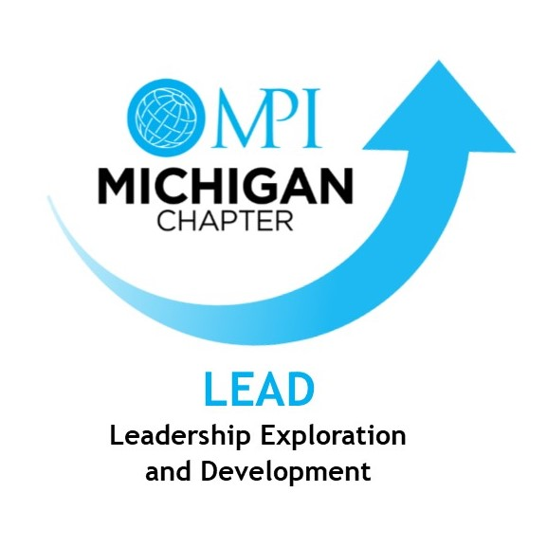

MPI Michigan Mentor Program
Mentee/Mentor Guidebook and Goals Form

Role: | Mentee | Mentor
Name (Include Designation)
Company:
Phone:
Cell:
Email:

List SMART (Specific, Measurable, Attainable, Realistic, Timely) Goal(s):

Timeline /Date(s): | Item | Date Completed

Agreement: | Mentee | Mentor
Signature:
Date:

Please complete this form by July 31, 2020 and return it to:
Sarah Dysinger, CTA, sarah.dysinger@gmail.com
.

