

**BOOM, we here we go with our first LIVE event since 2020!**

**We are thrilled to be hosting the Festive Event LIVE at the Head Office Ottawa on December 2. I know many of you are excited to see your friends and colleagues. The Festive event will focus on the uniqueness of the Head Office Ottawa where fun activations and ample networking are planned for the attendees, from a games area to speak easy and traditional boardrooms. I know you will want to join in on the fun so we have created some engaging opportunities for our valued partners.**

**Please see below available Partnership Opportunities, and let me know if any of them interest you…..please keep in mind these will not last so call me today☺**

**Daniela Stucki**

[**partnerships@mpiottawa.ca**](mailto:partnerships@mpiottawa.ca)

**613-731-5715**

**Championship Partner (1)**

**$4,500**

**Games Area**

Use of games in that space area: pool table, foosball, dartboard

Additional games available for use: board games, beanbag toss

Space would be from column to column and carpet to carpet apx. 20’ x 20’, up to 20 people

**Deliverables:**

* Exclusive use of games area, most visible and central space in the venue
* Your logo displayed during the event and MPI website
* Mention from MC during the event
* Event attendees’ contact information
* 2 complimentary registrations

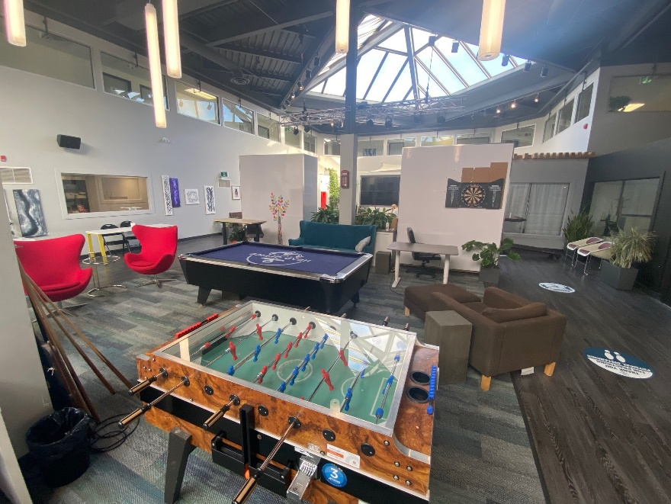

**Gold Partner (1)**

**$3,500**

**Sneaky Pete’s Speakeasy**

Exclusive use of the hidden Sneaky Pete’s. Guests will enter through the telephone booth to discover our hidden Speakeasy.

Space can accommodate apx. 5-8 guests at a time

**Deliverables:**

* Exclusive use of speak easy as your own intimate and personal space
* Your logo displayed during the event and MPI website
* Mention from MC during the event
* Event attendees’ contact information
* 2 complimentary registrations

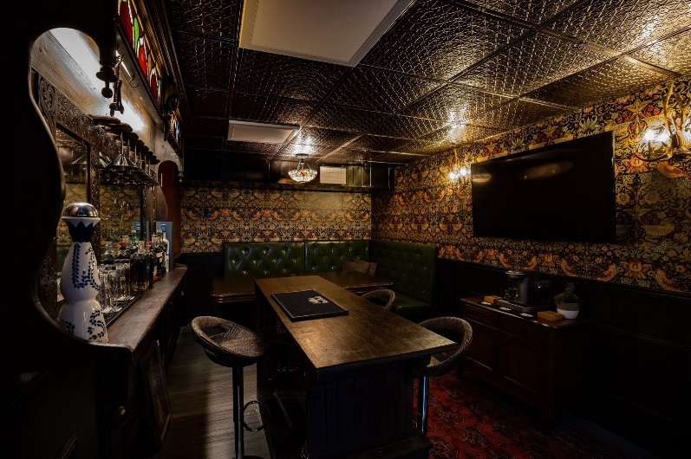 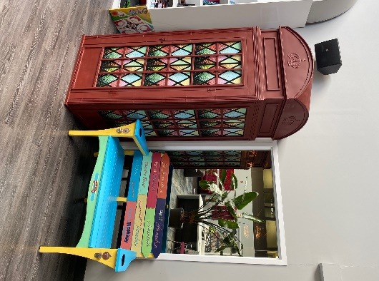

**Silver Partner (1)**

**$2,500**

**The Batcave**

Host your own personal multifunction room, up to 20 guests at a time, your topic, open flow

Private space

Exclusive use of this space

Includes monitor on the wall and any furniture as needed

Tables and chairs in the center can be removed, the counters along either side cannot. There are also now lockers in this space that we can't move.

Dimensions: 20 x 20

**Deliverables:**

* Exclusive use of space
* Your logo displayed during the event and MPI website
* Mention from MC during the event
* Event attendees’ contact information
* 1 complimentary registrations

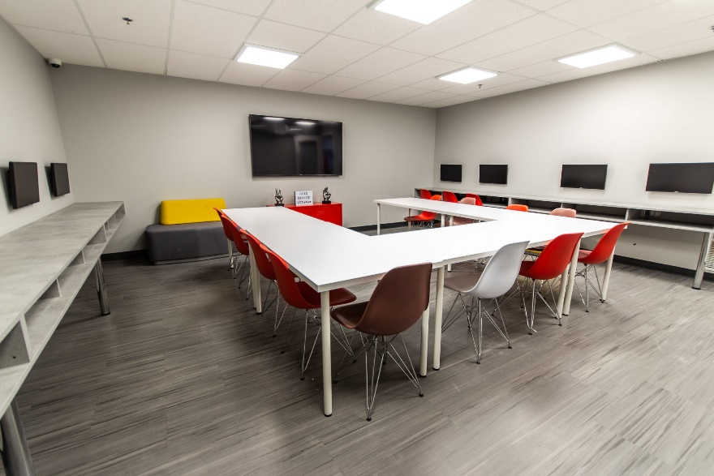

**\*note only one TV is in this room now, no screens long the right or left wall**

**Silver Partner (1)**

**$2,0000**

**Catalina Wine Mixer**

Exclusive use of this space to transform as you wish. Private soundproof space - apx. 15’ x 12’. Includes use of monitor.

**Deliverables:**

* Exclusive use of space
* Your logo displayed during the event and MPI website
* Mention from MC during the event
* Event attendees’ contact information
* 1 complimentary registrations

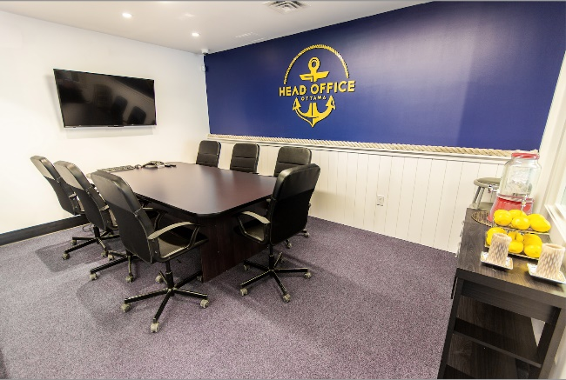

**Silver Partner (1)**

**$2,0000**

**The Wexford Suite**

Exclusive use of this space to transform as you wish. Open concept with no ceiling - apx. 15’ x 15’. Space includes use of the monitor.

**Deliverables:**

* Exclusive use of space
* Your logo displayed during the event and MPI website
* Mention from MC during the event
* Event attendees’ contact information
* 1 complimentary registrations

