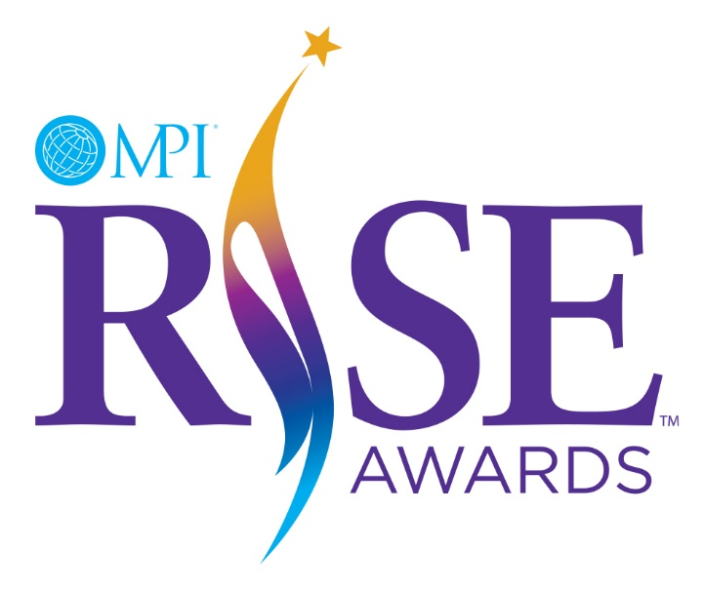
2025 RISE Award Timeline

September 10, 2024 | RISE Award Nominations & Applications Open
November 1, 2024 | Nominations Close
December 10, 2024 | Applications Close
January – February, 2025 | RISE Awards Committee reviews eligible applicants
February – March, 2025 | Applicants notified of status  Finalists receive interviews
March 2025 | 2024 Recipients are selected & ratified
April 2, 2025 | Finalists announced at MPI’s GMID Broadcast
April 2025 | Award Notifications to all Finalists
June 17-19, 2025 | RISE Award recipients announced at WEC25 St. Louis

